Lab 01

1. A screen shot of a computer program

   AI-generated content may be incorrect.
2. A screen shot of a computer program

   AI-generated content may be incorrect.
3. A black screen with white text

   AI-generated content may be incorrect.
4. 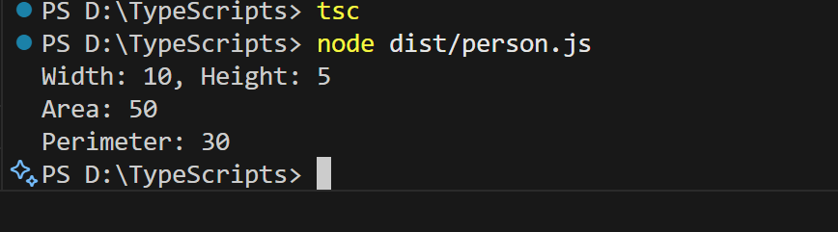
5. A screen shot of a computer

   AI-generated content may be incorrect.
6. A screenshot of a computer program

   AI-generated content may be incorrect.
7. A screen shot of a computer

   AI-generated content may be incorrect.
8. 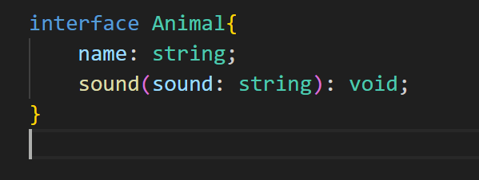
9. 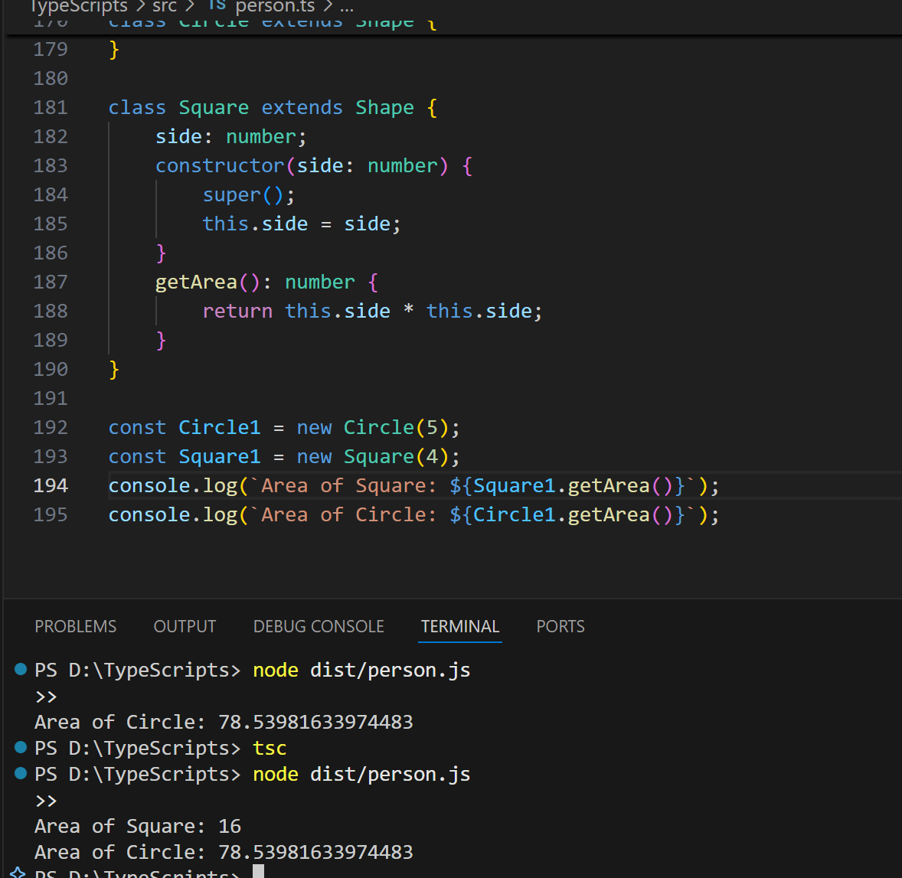
10. A screenshot of a computer program

    AI-generated content may be incorrect.
11. A screen shot of a computer

    AI-generated content may be incorrect.